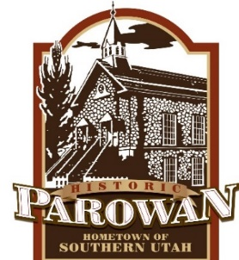

INVITATION TO BID
SALE OF SURPLUS EQUIPMENT

Parowan City has a number of surplus items and equipment for sale. This equipment has been taken out of regular service and will be sold in “as is” condition with no warranty expressed or implied. Parowan City urges prospective bidders to view the equipment before submitting a bid.

The following equipment will be available for inspection in the parking lot at 405 N. Main:

- 2000 Ford Ranger (for parts) Minimum Bid $500
- 1979 Intl. Jetter Truck No Set Minimum Bid
- 2007 Dodge Charger Minimum Bid $1250

The following equipment will be available for inspection by appointment only. Please email Justin Dalley (include your name and phone number) at justin@parowan.org:

- Bent and Damaged Livestock
Panels No Set Minimum Bid
- 170’ x 28’ Canopy/Shed (trussed roof) No Set Minimum Bid
- 2009 Ex Mark Bagging Mower Minimum Bid $2000

Bids must be placed in a sealed envelope marked “Surplus Equipment Bid”. The envelope should be addressed to:

Mr. David C. Matheson
Parowan City Manager
PO Box 576
35 E 100 N
Parowan, UT 84761

Sealed bids must be received by the Parowan City Administrative Office prior to 12:00 p.m. (MDT) on Friday, April 30, 2021.

Parowan City reserves the right to accept or reject any or all bids in total or in part and to waive informalities and irregularities, as it may deem to be in the City’s best interest.

Posted 3/31/21 through 4/30/21
Callie Bassett, CMC
Parowan City Recorder

