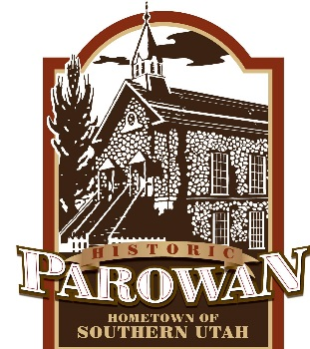 **NOTICE OF PUBLIC HEARING**

**REGARDING FY2021 BUDGET AMENDMENTS**

Parowan City hereby gives notice that on Thursday, November 12, 2020 at 6 p.m. a public hearing will be held in the Parowan City Council Chambers, 35 E. 100 N., Parowan, Utah, to hear comments regarding amending the Fiscal Year 2020-21 budget.

The public is invited to attend and offer comments to the City Council. A copy of the FY20-21 budget and its amendments are available for public inspection at the Parowan City Hall, 35 E. 100 N., Parowan, Utah, 435-477-3331. Written comments may be submitted to Callie Bassett, Parowan City Recorder at the aforementioned address, or mailed to P.O. Box 576, Parowan, Utah, 84761.

________________________________

CALLIE BASSETT, CMC

PAROWAN CITY RECORDER

POSTED: November 4, 2020

*NOTICE: In compliance with the Americans with Disabilities Act, individuals needing special accommodations or assistance during this meeting shall Callie Bassett, City Recorder, at 435-477-3331 at least 24 hours prior to the meeting.*