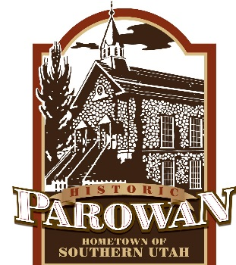 **NOTICE OF PUBLIC HEARING**

Parowan City hereby gives notice that on Thursday, May 13th, 2021 at 6 p.m., a public hearing will be held in the Parowan City Council Chambers, 35 E. 100 N., Parowan, Utah, to receive comments regarding adopting the Tentative Budget for the Fiscal Year 2021-22. The public is invited to attend and offer comments for or against the tentative budget. Written comments may also be emailed to [callie@parowan.org](mailto:callie@parowan.org), mailed to P.O. Box 576, Parowan, Utah, 84761 or submitted to the City Office at 35 E. 100 N. A copy of the tentative budget will be available for public inspection at the City Office, posted online at [www.parowan.org](http://www.parowan.org), and on the Utah Public Notice Website at utah.gov/pmn/index.html.

CALLIE BASSETT, CMC

PAROWAN CITY RECORDER

POSTED: May 4, 2021

*NOTICE: In compliance with the Americans with Disabilities Act, individuals needing special accommodations or assistance during this meeting shall Callie Bassett, City Recorder, at 435-477-3331 at least 24 hours prior to the meeting.*